UNIVERSITY OF BEDFORDSHIRE
DEPARTMENT OF COMPUTER SCIENCE AND TECHNOLOGY
CIS016-1 [MCCT]
Assignment-2
Last Submission Date/Time:
WEEKLY PROGRESS REPORT FORM
STUDENT NAME | Rojan Maharjan | FACULTY/TUTOR |  | Season Maharjan
ASSIGNMENT TITLE | Spendwise – Budget Manager App
REPORT NO | 4 | DATE | 2025/11/29

Summary of Progress (including any problems) | During Week 3, I focused on transforming the static frontend into a functional, data-driven interface connected to a MongoDB-based backend API. My primary role this week remained frontend development, with emphasis on API integration, real-time UI updates, and improving usability across screens.  Key achievements include:  - Connected Frontend with MongoDB Backend APIs  - Integrated real API endpoints for:  - User Login  - Add Expense  - Fetch Categories  - Fetch Expenses History  - Data is now dynamically fetched from and sent to the backend server connected to MongoDB (no SQLite or local database used).  - JWT Authentication Integration  - Implemented secure token handling using flutter_secure_storage for storing JWT tokens.  - Ensured protected routes (Dashboard, Add Expense, Reports) only load after successful authentication.  - Frontend-State Synchronization  - Implemented state management to update UI immediately after adding or deleting an expense.  - Added loading indicators and error messages during API calls to improve UX.  - Reports & Charts Connected to Real Data  - Replaced hardcoded values in charts with live MongoDB data.  - Implemented monthly expense trend visualization using fl_chart with real backend responses.  - Offline Handling (Without SQLite)  - Designed temporary in-memory caching for newly added expenses when the device is offline.  - Implemented a basic sync mechanism where cached data is sent to MongoDB once the connection is restored.  - UI/UX Improvements  - Improved layout consistency and spacing for small and large screens.  - Added visual status indicators for online/offline mode.  - Improved navigation flow between Login → Dashboard → Add Expense → Reports.  Problems / Challenges Faced  - Faced issues with token expiration during some API calls.  → Solved by adding a token refresh mechanism and redirecting to login when the token becomes invalid.  - Inconsistent responses from backend during heavy testing caused UI crashes at times.  → Resolved by implementing better exception handling and null safety checks in Dart.  - Managing real-time UI updates with async MongoDB data required restructuring some widget trees.  → Resolved using FutureBuilder and custom state refresh methods.
Plan for next week | n/a
Supervisor’s
Comments

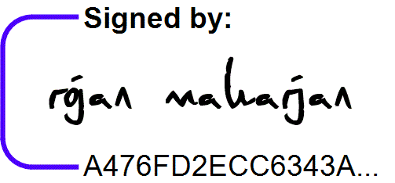  2025/11/29 |   2025/11/29
Student Signature & Date/Time | Supervisor Signature & Date/Time

